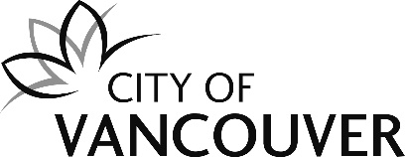 |  | ARTS & CULTURE - ACCS  CULTURAL GRANTS PROGRAMS

COMMUNITIES AND ARTISTS SHIFTING CULTURE (CASC) PREVIEW OF APPLICATION & ASSESSMENT CRITERIA

(UPDATED JANUARY 2026)

This is a preview of the application form only. Please use the online application portal at VanApply to submit your application.

Please carefully review assessment criteria and weighted scoring in the following sections, starting on page 4:
2.0 CREATIVE VISION (25%)
3.0 COMMUNITY PARTICIPATION & IMPACT (20%)
4.0 EQUITY, ACCESSIBILITY & INCLUSION (35%)
5.0 PROJECT PLAN & BUDGET (20%)

1.0 GENERAL INFORMATION (not scored)

CASC 1.1
Grant request amount
Maximum request is $15,000
$ Amount

CASC 1.2
Name or title of proposed project
Provide the proposed project name or title. This may be used for external reporting purposes.
Maximum:10 words.

CASC 1.3
One sentence description of the proposed project.
This description may be used for external reporting purposes.
Maximum: 25 words

CASC 1.4
Organization’s mission, vision and values as submitted in the Organization’s Eligibility Profile.

CASC 1.5
Is the core purpose of your organization, as expressed in its mission, vision and values, to create, produce, or present artistic and/or cultural works, or to serve the arts and culture sector?
Choose one:
- Yes
- No

NEW: If your organization does not have an arts and culture mandate, your project may be assessed as a lower priority for funding as there are limited resources available in the cultural grants budget. Please review the list of previous grant recipients here Cultural Grants Program | City of Vancouver.

CASC 1.6
Organization’s last actual budget (expenses)
$ Amount

CASC 1.7
Organization’s last fiscal year end
Date (YYYY/MM/DD)

CASC 1.8
Board of Directors List
Attach a list of the organization’s Board of Directors, including name, position, start date and experience. You may also attach your most recent List of Directors and Registered Office that you filed with the Province of BC Registrar of Companies.

CASC 1.9
Sponsored Application
Is this a sponsored application for an individual artist or collective?
- Yes
- No

If yes:
CASC 1.9.1
Name of the sponsored artist or collective

CASC 1.9.2
Discuss the working relationship between the sponsoring organization and artist(s), and whether the sponsor organization has a mandate to serve the same equity-denied community(ies) as the individual artist or collective.
Maximum: 250 words

CASC 1.10
Project Type
What type of arts or culture activity are you proposing? Refer to the CASC Grant Information Guide for examples of activities in each project type.
Choose one:
- Community-engaged arts project
- Festival, celebration or large-scale parade
- Artistic creation or production

CASC 1.11
Primary Artistic Discipline
What is the primary artistic discipline of the activity you are proposing?
Choose one:

- Community Arts/Social Practice
- Cultural Heritage
- Dance
- Deaf, Disability and Mad Arts
- Indigenous Arts
- Literary
- Digital Media & Film
- Multidisciplinary
- Music
- Theatre
- Visual Arts
- Other, please specify...

CASC 1.12
Is the proposed project taking place outdoors on City of Vancouver or Vancouver Park Board property?
Choose one:
- Yes
- No

If Yes:
For projects taking place outdoors on City of Vancouver or Vancouver Park Board property, a permit or approval is required. Evidence of permits and/or approvals may be a condition for release of grant funds.
Visit the City's website for more information: http://vancouver.ca/doing-business/event-permits.aspx.

CASC 1.13
Have you submitted an interim or final report on your last CASC grant-funded project?
Choose one:
- Yes
- No
- I am a first-time applicant

If Yes:
Please enter the reference number from your last CASC grant-funded project (i.e. the ID/file number beginning with “CASC-“ in VanApply and included in the grant confirmation letter):

If No:
If you have not yet completed your report, please save your progress on your application and then complete an interim or final report on your last CASC grant-funded project by going to “My Applications” from the Dashboard and completing the outstanding reporting tasks attached to your previous CASC application(s) only. Once you have completed your report, please resume your application.

CASC Program Objectives
The questions in this part of the application focus on the proposed project. Specific criteria for each section appear at the top of each page.

We want to understand how your project supports equity, access and inclusion in Vancouver’s arts and cultural communities. You are encouraged to include information throughout your responses that reflect how your project aligns with the key directions of Culture|Shift, Vancouver’s Culture Plan 2020-2029, particularly in the areas of reconciliation and decolonization, cultural equity and cultural redress, and accessibility.

2.0 CREATIVE VISION (25%)

CRITERIA
- A clear focus on arts and culture that actively involves and provides meaningful opportunities for artists and cultural workers
- A compelling, timely artistic exploration that aligns with the organization’s mandate

CASC 2.1
Detailed Project Description
Describe the proposed project and its context. What is the creative vision? What is the inspiration for this project? Why is this project important in this moment in time? Please include when and where the project will take place.

Maximum: 400 words

3.0 COMMUNITY PARTICIPATION & IMPACT (20%)

CRITERIA
- Activities are located within Vancouver unless led by either xʷməθkʷəy̓əm (Musqueam), Sḵwx̱wú7mesh (Squamish) or səlilwətaɬ (Tsleil-Waututh) Nation members and held in their traditional homelands
- A clear understanding of and connection with the community the project aims to serve
- Thoughtful community engagement practices
- Effective marketing, communication and outreach strategies to promote the project to the intended audience
- Creative methods of assessing the impacts and outcomes of the project

CASC 3.1
Audience
Who is the primary audience(s) (i.e., general public, members, individuals, communities, artists, organizations) that the project aims to serve? How is this project relevant to the intended audience?
Maximum: 250 words

CASC 3.2
Community Engagement
Will there be opportunities for the audience to engage in activities that are complementary to or further explore the artistic work? (i.e., talkbacks, workshops, facilitated discussions, ancillary exhibitions, etc.)
- Yes
- No

If Yes:
CASC 3.2.1
Please describe the activity(ies).
Maximum: 250 words

CASC 3.3
Promotion
How will you promote the project to the intended audience? How is this outreach and promotion plan relevant to the intended audience?
Maximum: 150 words

CASC 3.4
Proposed Project Statistics
Provide the projected statistics for the proposed project.

CASC 3.4.1
Number of artistic works created

CASC 3.4.2
Number of public activities (performances, presentations, exhibitions, workshops, readings, screenings)

CASC 3.4.3
Total attendance at public activities (i.e. paid and unpaid or free using best estimates for unticketed events)

CASC 3.4.4
Number of artists involved

CASC 3.4.5
Number of volunteers involved

CASC 3.5
Impact and Evaluation
What do you want to achieve through this project, both qualitative and quantitative? How will you assess the impacts and outcomes?
Maximum: 200 words

4.0 EQUITY, ACCESSIBILITY & INCLUSION (35%)

CRITERIA
- Project and organizational leadership and team has the relevant skills, permission, knowledge, and lived experience necessary to lead and undertake the project.
- Actions are being taken to support inclusion of underrepresented artists and audiences.
- Thoughtful reflection on barriers to access and participation for artists and audiences.
- Resourced accommodation and accessibility plans are in place to address any physical, cognitive, financial, linguistic, cultural, social, and geographic barriers to participation for audiences and key contributors for both in person and online events.
- Local First Nations are acknowledged in a meaningful way.
- Cultural protocols are respected where proposed projects engage with or represent Indigenous culture, stories or people.

CASC 4.1
Key Contributors
Tell us about the artists and cultural workers that have leadership, decision-making roles, and creative input in the project. What are their roles in the project? In their own words, why did they choose to participate in this project? What experience(s) do they bring to the project?

Only include the key contributors with decision-making roles (artistic, creative, administrative, community partners). Indicate whether their participation is confirmed or pending.
Maximum: 200 words each

CASC 4.2
Accessibility
Approximately 1 in 5 Canadians identify with having a disability or barrier to participation, visible or invisible. How do you create safe(r) spaces for creative expression and participation? How do you determine and respond to the access needs of your key contributors and audience members?

Refer to the Glossary in the CASC Information Guide for examples of best practices in Equity, Access and Inclusion and definitions of key terms such as Intersectionality and Diversity.
Maximum: 400 words

CASC 4.3
Host Nations
This project is taking place on the unceded territories of the xʷməθkʷəy̓əm (Musqueam), Sḵwx̱wú7mesh (Squamish) and səlilwətaɬ (Tsleil-Waututh); they have unique rights and title in these territories. What is your relationship to these local Nations and in what ways are you acknowledging them?
Maximum: 250 words

CASC 4.4
Working with Local Nations
Does the proposed project involve working with Indigenous artists or cultural practitioners of the xʷməθkʷəy̓əm (Musqueam), Sḵwx̱wú7mesh (Squamish) and səlilwətaɬ (Tsleil-Waututh) and/or is it planned to take place on a site of cultural significance to local Nations including shoreline areas, Stanley Park, Vanier Park, Locarno Beach, or Jericho Beach?
Choose one:
- Yes
- No

If Yes:
CASC 4.4.1
Discuss how you have addressed the following:
- Cultural Protocols – Local First Nations and urban Indigenous people have diverse protocols that govern how cultural expressions and collaborations are developed, shared, and stewarded. How will you respect the specific cultural protocols relevant to your collaborations?
- Consent, Credit, Leadership and Compensation – How will you ensure that Indigenous artists, knowledge keepers, and collaborators have given consent, are credited appropriately, and are in leadership positions in the development or co-development of the project? How are they being compensated and resourced appropriately for their involvement?
- Cultural Safety – How will you create or partner to create respectful and relevant spaces, venues and programs where Indigenous people’s work and health are not compromised by power imbalances, discrimination, stereotypes, and unconscious bias?
- Sites of Cultural Significance – A very limited number of new works will be considered for Stanley Park, Vanier Park, Locarno Beach, or Jericho Beach at this time. Sites of significance to local Nations, including shoreline areas, will only be considered with evidence of xʷməθkʷəy̓əm (Musqueam), Sḵwx̱wú7mesh (Squamish) and səlilwətaɬ (Tsleil-Waututh) support.
Maximum: 250 words

5.0 PROJECT PLAN & BUDGET (20%)

CRITERIA
- Project plan is clear and feasible
- Budget is realistic, balanced, and is sufficient to complete programming and meet goals
- Budget includes other sources of cash revenue and support in addition to this grant request
- There is a clear need for City support
- Total combined cash contributions from all City sources (including this grant, other City programs, and Park Board contributions) can be up to 75% of the cash budget, to a maximum of $15,000 (not including in-kind goods and services).
- Detail is provided on compensation for artists and other key project contributors that aims to meet industry standard rates
- Budget includes costs to provide accommodation and accessibility support for artists, project contributors and audiences

CASC 5.1
Project Plan (Mandatory)
List the key project activities and estimated dates for the phase of the project you are applying for. Examples include research, workshops, readings, rehearsals, promotion, exhibition/performance/publication dates.

Use the chart below
NEW: - ADDITIONAL INFORMATION CAN BE UPLOADED
 | Key Activities | Date From | Date To | Location
CASC 5.1.1
CASC 5.1.2
CASC 5.1.3
CASC 5.1.4
CASC 5.1.5
CASC 5.1.6

CASC 5.2
Proposed Project Budget
From the task list at top left, upload a projected budget to the task “Proposed Project Budget”.

You may use the template “Proposed Project Budget Form” that can be downloaded from the task list
- OR -
upload your own document.

Please ensure that your budget balances.

NEW TASK
CASC- Neighbourhood Activation
In which Vancouver neighbourhood(s) will your project take place? (Select all that apply, using the map below for reference).

- Arbutus Ridge
- Downtown
- Downtown Eastside
- Dunbar Southlands
- Fairview
- Grandview Woodland
- Hastings Sunrise
- Kensington Cedar Cottage
- Kerrisdale
- Killarney
- Kitsilano
- Marpole
- Mount Pleasant
- Oakridge
- Renfrew Collingwood
- Riley Park
- Shaughnessy
- South Cambie
- Strathcona
- Sunset
- Victoria Fraserview
- West End
- West Point Grey
- Online

Please note that if you select more than three neighbourhoods, you will be asked to explain why. These neighbourhoods should also be reflected in CASC 5.1, the key activities list in your project plan. A larger version of this map is here: City of Vancouver Neighbourhoods
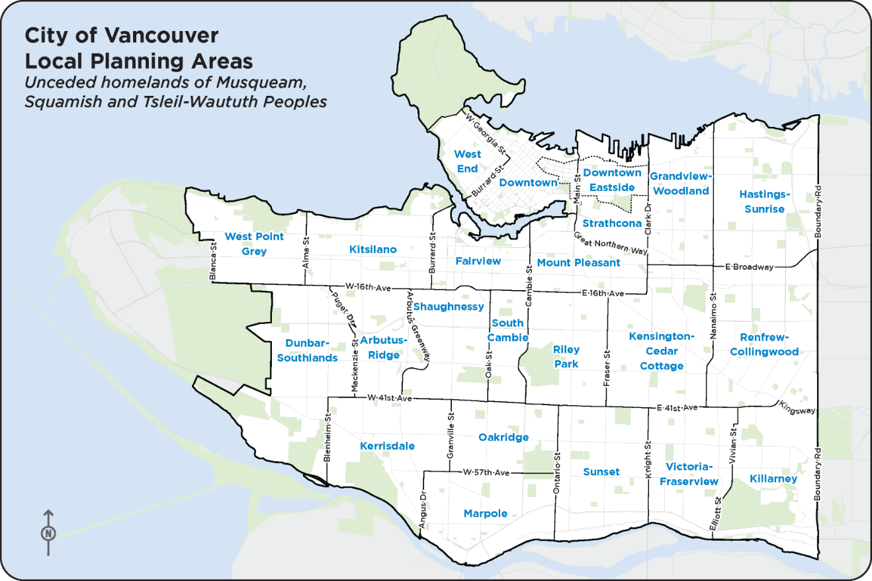
ADDITIONAL DOCUMENTS

- Board of Directors List: Attach the Board of Directors list with names, positions, affiliation/experience, and terms. (see CASC 1.8 above)

- Key Contributors List (see CASC 4.1 above)

- Proposed Project Budget (see CASC 5.2 above)

- Financial Statements: Attach the Board-signed financial statements for the most recently completed fiscal year (i.e. audited, review engagement, notice to reader)

- Project Support Material (Optional): Provide digital samples from participating artists or recent work of the organization within the past three years

  - Upload your Project Plan document to this section to supplement the information in the chart in CASC 5.1

- Final or interim report on previous CASC-funded project (to be completed with previous application in VanApply)

