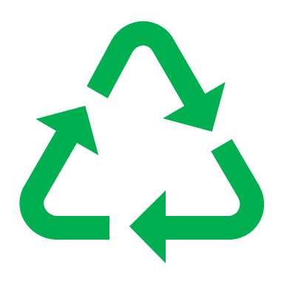
New Resident Welcome Letter Template
Recycle Right

Dear Resident,

Welcome to the building!

We have provided this Zero Waste welcome letter to introduce you to our waste diversion program, and to provide you with the information needed for you to sort your waste easily and properly.

Taking part in our building’s waste diversion programs (e.g., Blue Bin recycling and Green Bin organics) is not only mandatory, but also helps to reduce garbage volume and less garbage means lower collection fees.

Recycling is good for the economy and the environment! Making new products out of recycled materials saves energy and resources, reduces emissions, and extends the life of the landfill.

Please remember these 3 basic rules when recycling:

- Always recycle your empty cans, bottles, containers, paper and cardboard into the Blue Recycling Containers and Paper Bins.

- Recycle your food scraps, plant material and food soiled paper in the Green Bins.

- Place the recyclable items directly into the bin loose – Do not bag the recyclables.

If you need more information on how to sort your waste, you can contact me, or use the online sorting tool Waste Wizard: vancouver.ca/wastewizard.

If you have any questions, please contact (insert name) at (insert phone number or email address).

Thanks for your interest and cooperation.

Sincerely,

Building Manager/Condo Strata Board/Building Owner

